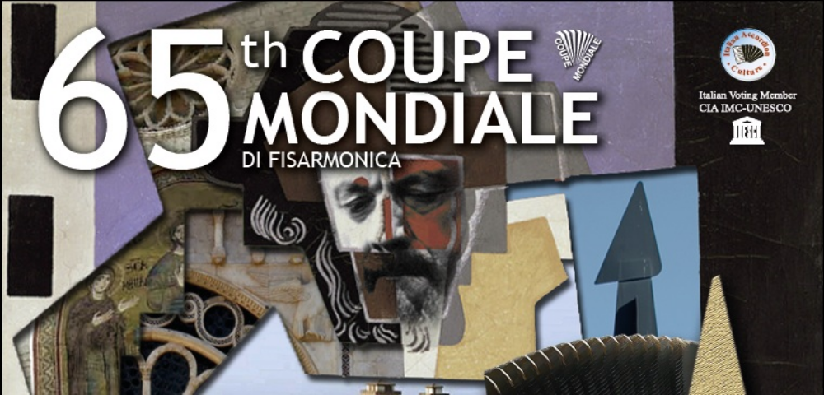
65° ACCORDION COUPE MONDIALE: musical excellence in Spoleto
Competitions, concerts and tours in the area
19th-26th of August 2012

The 65° edition of the CIA Accordion Coupe Mondiale (Confédération Internationale des accordéonistes) for classical and varieté accordionists will take place in Spoleto near Perugia, in the wonderful setting of the Teatro Nuovo "Giancarlo Menotti". The competition returns to Italy after a 50 year gap and the town of Spoleto will have the most successful musicians and ensemble in the World after Glasgow (Scotland), Auckland (New Zealand), Varazdin (Croatia) and Shaghai (China).

The award categories are: varieté, classic, digital and ensemble. The event, organized by the IAC (Italian Accordion Culture) and Strumenti&Musica Festival, is full of excellent events and guests to complement the high artistic level of competing participants, all of whom are winners of their respective national selections.

The first event will take place at 7.00 p.m. of Saturday 18 August in “Chiostro di San Nicolò” with the concert of the international artist and Trophée Mondial de l'Accordéon Winner, proudly appears in concert in his home town of Spoleto Mirco Patarini, in collaboration with “Spoleto Mama Open” and “Spoleto a colori”.

At 10.00 p.m. of Sunday 19 August in the “Castello di Pissignano” (Campello sul Clitunno), Samuele Telari will play: the young boy Winner of the 2009 and 2010 editions of "Strumenti&Musica Festival" and 2nd Prize Winner of the 2009 CIA Junior Coupe Mondiale in Auckland, New Zealand, Samuele Telari lives in Spoleto. This concert is presented in cooperation with "Tra Arte Musica e Video" - Associazione "La Fortezza".
Monday 20 August at 7.00 p.m. in Albornoz Palace Hotel will take place “Dance&Music”, performance of contemporary dance featured by "ContemporaneaMente Gruppo Danza" with Arianna De Angelis and Sara Libori from Spoleto. The duo "Una Sinistra", comprises Alexander Selivanov and Yulia Amerikova. Both from Moscow, Russia, Alexander was the winner of 57th CIA Coupe Mondiale in 2004 and in duo with Yulia, the winner of the CIA International Competition for Ensemble Music in 2007. Reception will follow.
Tuesday 21st August in Teatro Nuovo “Giancarlo Menotti” (“Sala XVII Settembre”) at h. 12.00 will take place the Conference "Music and Culture: Organizational Challenges" with Prof. Antonio Corsi, President of the "Tavolo Nazionale for the promotion of Popular Music and Amateur Musicians". At h. 5.00 p.m. Contestant Draw for Playing Order and at 9.00, the Teatro Nuovo “Giancarlo Menotti” will host the opening concert of Coupe: important guests will perform tango on the stage. The ensemble, winner of ”Astor Piazzolla Music Award”, will start the concerts then: “Giuliana Soscia&Pino Jodice Duet”: accordion and piano duo, taking a fascinating voyage through the rhythms of Tango, while offering a Jazz rendering of some compositions by Astor Piazzolla. “Peter Soave Quartet” concert accordion and bandoneon – music of Astor Piazzolla: Aldo Pagani decided to bring together a group of excellent musicians and friends to celebrate the music of the legendary Maestro Astor Piazzolla in memory of the 20th anniversary of his passing away on 4th July 1992. A tribute to Piazzolla by his closest collaborators and friends, featuring Peter Soave, winner of CIA Coupe Mondiale in 1984; "Aldo Pagani Editore", in the name of Aldo Pagani, producer, publisher and friend of Astor Piazzolla for more than twenty five years, will award this annual International Prize, established in 1993, dedicated to the great Argentine Composer: ”Astor Piazzolla Music Award”. The choir of cultural association “Bisse” will close the evening: the umbrian choir conducted by M° Claudio Scarabottini, based in Spoleto, will introduce the audience to the popular traditions of the World through music.

Wednesday 22nd and Thursday 23rd, all at the Teatro Nuovo “Giancarlo Menotti”, location in which take place the whole competition, from 9.00 a.m. and all day long, there will be the contest where 100 competitors from China, Russia, Finland, United Kingdom, New Zeland, Brasil and other places in the World will participate.

Friday 24th August, the competition will continue, while at 9.00 p.m. the evening concert will take place with “Fisorchestra Luciano Fancelli”, conducted by M° Marco Gatti, Founded in 1989, the orchestra aims to promote the music around the world of the composer Luciano Fancelli, from Umbria. Then the “Orquestra de Acoreon de Brusque” conducted by M° Bruno Moritz: Coming all the way from Santa Catarina State to Spoleto, to present their traditional music of southern Brazil. The Accordion Ensemble “Concertino”, based in Moldova, comprising seven accordions, bass, piano and drums, will perform famous pieces from the classic, popular and jazz repertoire.

During the event, Mirco Soprani, Mayor of Castelfidardo and Vincenzo Canali, President of International Accordion Museum will award the “Paolo Soprani” prize, now in its third edition. At the end, the German “Akkordeonorchester di Hof”, conducted by M° Torsten Petzold will play a variety of classical pieces, original compositions and arrangements from well known repertoire, then the “World Accordion Orchestra” (WAO VI): founded by Joan C. Sommers for the CIA, for the sixth time, competitors in the Coupe Mondiale, delegates, friends and members of the Jury will join together forming the largest Accordion Orchestra in the world.
Saturday 25th August the final competition will take place with Prize Giving and Awards Ceremony. At 9.00 p.m. will take place Closing concert of the 65° Coupe Mondiale, where Nenad Ivanovic (Serbia), winner of 64° edition and the winners of this year will perform. Concert player M° Wladimir Zubitsky Ukrainian accordion Soloist, Composer, Conductor and winner of the CIA Coupe Mondiale in 1975 will play accompained by string orchestra “Giuseppe Tartini” based in Latina, it’s one of the most important in Italy cooperating with many famous musicians and directed by M° Marco Gatti, conductor and composer, working with orchestras across Europe and with great musicians.

Sunday 26th August, at 6.00 p.m. in Albornoz Palace Hotel “Farewell Jazz concert” with renowned Italian accordionist Antonio Spaccarotella.

Every lover of music and of travel can also discover Umbria by way of a special tour which will show them in the most evocative locations of the region, starting with Spoleto itself. We have a single goal: to make each participant fell as if they belong to this territory by getting to know the places and traditions from within, to enjoy the smells, sounds and colors of this land. During the tours, people will visit the towns of Spoleto, Assisi, Bevagna for a Medioeval Lunch, Spello, Montefalco for a wine tasting, Marmore Falls, the ancient village of Solomeo for cashemere shopping. Some tours will be organised so that the guests have the opportunity to attend the concerts and evening events.

Info:
Ilaria Bellini
Email: direttore@strumentiemusica.com
mob. +39 334 9796339

www.coupemondiale.org

